Research Article or Review Article

Optimal mechanical harvester route planning for sugarcane field operations using particle swarm optimization
Woraya Neungmatcha and Kanchana Sethanan*
Research Unit on System Modeling for Industry, Department of Industrial Engineering, Faculty of Engineering, Khon Kaen University, Khon Kaen, 40002, Thailand.
*Corresponding author. Tel.: +00-0000-0000; Email address:

Abstract
This is an instruction for manuscript preparation for publication in Engineering and Applied Science Research (EASR). The abstract should contain a single paragraph describing objective, methodology and a summary of important results. Its length should not exceed 300 words.
Keywords: 3-6 keywords, separated by commas, the first letter of each keyword must be capitalized.

1. Introduction
Start the first paragraph and subsequent paragraphs with indentation. Use tab stops or other commands for indents but do not use the space bar. Primary headings should begin at the left margin in boldface.
This article demonstrates an example for you to prepare your article for submission to Engineering and Applied Science Research (EASR). Please strictly follow the guideline and use Microsoft Word for Window. The length shall not exceed 15 pages or 10,000 words.

2. Materials and methods

2.1 Paper size and margins

Manuscript should be created using MS Word. Please use A4 paper size (21x 29.7 cm), one-column format. All margins must be 2.54 cm and manuscript should have page numbers and line numbering, and be typed in double spacing. Figure and tables should be placed as close as possible to where they are mentioned in the text.

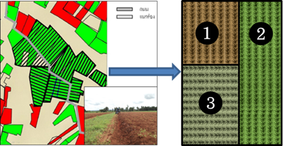
Figure 1 Direction of sugarcane planting groves

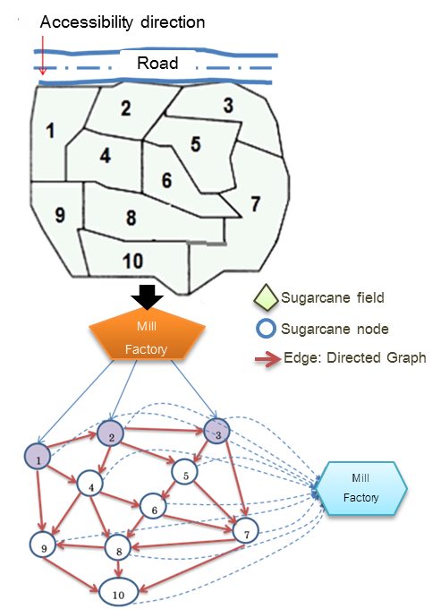
Figure 2 Directed graph of harvester

2.1.1 Structure of article

The article content will, in general, consist of the following headings: Introduction, Materials and Methodology, Results and Discussion, Conclusion, Acknowledgements, and References.

2.1.2 Figure and tables

- If your electronic artwork is created in a Microsoft Office application (Word, PowerPoint,
Excel) or the application used other than Microsoft Office, when your electronic artwork is finalized, please 'Save as' or convert the images to TIFF or JPG file, use a resolution minimum of 300 dpi.
- Line drawings should be of high resolution and high contrast. For color or greyscale photographs (halftones), use a minimum of 300 dpi (.TIFF or .JPG).
- Provide captions to figure separately and submit each figure as a separate file.
- Do not upload Excel files or images for tables. Use the table function of Microsoft Word.

3. Results

The research results should be presented clearly and right to the point with accompanying figures and tables. These figures and tables should be referred to in the content. Explanation must not repeat what is already given in the content.

Table1 Design of test problems
Problem | n | Sp |  | L
1 | 10 | 2 | 200 | 500
2 | 15 | 2 | 150 | 1000
3 | 20 | 2 | 150 | 1000
4 | 30 | 2 | 150 | 1500
5 | 50 | 2 | 100 | 1500

4. Discussion

Research discussion is aimed at persuading readers by comparing with other research studies and proposing possible solutions or useful suggestions for solving certain research outcomes, etc. Research results and discussion can be written in one section.

5. Conclusions

The conclusion of points and important research elements should not be too long. Your article should be reviewed by all co-writers before submission

6. Acknowledgements

Acknowledgements is for the purpose of showing gratitude to research supporters. It should not be long. Your article should be reviewed by all co-writers before submission.
7. References

The References part should follow the Vancouver style, and only in English. Please ensure that every reference cited in the text is also present in the reference list. Use an Arabic number in parenthesis after the referred statement. For example, [1] or [2-4, 8, 10] refers to Author 1 or 2, 3, 4, 8, 10 ordering from 1, 2, 3,...to the last number which appear in the reference list.

7.1 Example of references
Journal/Article
Authors. Title of article. Title of Journal. Year;Vol.(No.):Page.
[1] Mostofinejad D, Khozaei K. Effect of GM patterns on ductility and debonding control of
FRP sheets in RC strengthened beams. Construct Build Mater. 2015;93:110–20.

Book
Authors. Title of book. Edition. Place of publication: Publisher; Year.
[2] Murray PR, Rosenthal KS, Kobayashi GS, Pfaller MA. Medical microbiology. 4th ed. St. Louis: Mosby; 2002.
Chapter in book
Authors. Title of a chapter. In: editor. Title of book. Edition. Place of publication: Publisher; Year. Page.
[3] Meltzer PS, Kallioniemi A, Trent JM. Chromosome alterations in human solid tumors. In: Vogelstein B, Kinzler KW, editors. The genetic basis of human cancer. New York: McGraw-Hill; 2002. p. 93-113.
Conference proceeding
Editor. Title of article. Conference title; date of conference; place of conference. Place of publication: Publisher; Year.
[4] Harnden P, Joffe JK, Jones WG, editors. Germ cell tumours V. Proceedings of the 5th Germ Cell Tumour Conference; 2001 Sep 13-15; Leeds, UK. New York: Springer; 2002.
Conference paper
Authors. Title of article. In: editor. Conference title; date of conference; place of conference. Place of publication: Publisher; Year. Page.
[5] Christensen S, Oppacher F. An analysis of Koza's computational effort statistic for genetic programming. In: Foster JA, Lutton E, Miller J, Ryan C, Tettamanzi AG, editors. Proceedings of the 5th European Conference on Genetic Programming; 2002 Apr 3-5; Kinsdale, Ireland. Berlin: Springer; 2002. p. 182-91.

Thesis/Dissertation
Authors. Title [thesis/dissertation]. Place of publication: University; Year.
[6] Borkowski MM. Infant sleep and feeding: a telephone survey of Hispanic Americans [dissertation]. Mount Pleasant (MI): Central Michigan University; 2002.
Report
Authors/Department/organizer. Title. Place of publication: Publisher; Year. Report no.
[7] Smith P, Golladay K. Payment for durable medical equipment billed during skilled nursing facility stays. Final report. Dallas: Office of Evaluation and Inspection; 1994. Report no.: HHSIGOEI69200860.
Website
Author/Departmant/Organizer. Title of webpage [Internet]. Place: Publisher; Year [cited date of cited]. Available form: URL.
[8] Cancer-Pain.org [Internet]. New York: Association of Cancer Online Resources; c2000-01 [updated 2002 May 16; cited 2002 Jul 9]. Available from: http://www.cancer-pain.org/.

Author/Departmant/Organizer. Title of webpage [Internet]. Year [cited date of cited]. Available form: URL.
[9] Wikipedia. Generation Y [Internet]. 2011 [cited 2011 Jul 5]. Available from: http://en.wikipedia.org/wiki/Generation_Y.

